

**PLP Briefing**

**Updated: Labour’s campaign to save the coach sector**

**October 2020**

From the Shadow Transport Team.  
For further information email: [adam_scott@labour.org.uk](mailto:adam_scott@labour.org.uk)

**Contents**

**Top lines** 2

**Labour’s approach** 3

**Policy Outline** 3

**Reaction** 4

**FAQs** 5

**Model press release** 7

**Suggested Tweets** 8

**Model letter to the Government** 9

**Model letter to constituents** 11

# **Top lines**

* Tens of thousands of jobs are at stake as a result of coach operators struggling to secure business as the coronavirus pandemic goes on
* There has been no sector-specific support for coach companies, unlike for bus, rail and light rail operators
* The furlough scheme has been the only source of support up until this point for some companies, with industry experts estimating that 80% of coach companies were unable to access the Coronavirus Business Loan Interruption Scheme
* Industry experts estimate up to 4 in 10 companies could go bust and 27,000 jobs could be lost if no support is made available
* Many companies are family-owned small businesses. Livelihoods and homes are at risk
* Many of the difficulties arise from coach financing. Companies have been incentivised to purchase newer, cleaner vehicles in recent years and most are bought using financing of some kind. Some firms have been able to negotiate payment holidays during the crisis, but these will soon come to an end. Firms will then become liable for repayments but demand for coach services remains low, meaning a debt crisis is looming
* Coach operators are historically responsible borrowers
* The Government has argued that schools returning will provide coach companies with business, but many receive most of their income from summer trips, the tourism industry and sporting events
* According to the Confederation of Passenger Transport, over 23 million people visit UK attractions by coach every year, generating nearly 10 percent of the tourism sector’s total contribution to the economy
* Coaches are vital in areas where public transport options are limited and are often relied upon by older people or people with accessibility needs
* Labour is calling on government to explain why it has excluded coach companies from the sector-specific rescue packages it has arranged for bus, rail and light rail companies – and what plans it has in place to tackle the looming financing crisis, to protect jobs in the sector and to enable its long-term recovery

# **Labour’s approach**

* Labour has been clear we need to be a responsible opposition, working, if possible, to bring all sides to the table
* Those at threat of job losses are not helped by political points scoring, nor by Tory inaction
* Labour’s transport team has spoken to industry experts, trade unions, charities, Government Ministers and coach operators
* We’ve worked with stakeholders to produce a policy position that can help protect jobs and the wider supply chain
* We’ve called on the Government to come to the House of Commons and give frequent updates on these issues

# **Policy Outline**

Labour calls on the Government to provide a clear plan that protects jobs in the coach sector. The Government must act quickly to prevent coach operators, many of which are family-owned small businesses, from entering irrecoverable financial difficulties. Operators have been vocal about the issues, pointing out that homes and livelihoods are at stake.

The government needs to be much more targeted in the way it uses financial support – including the availability of loans – for firms in for industries that have faced the toughest challenges this summer and continue to face difficult months ahead.

According to the Confederation of Passenger Transport, up to 27,000 jobs are at risk, so it is paramount that the Government acknowledges the scale of the issue and moves quickly to ensure businesses are supported appropriately.

At the same time, the Government must also provide clearer guidance to operators and stakeholders in the tourism industry so that, where it is possible to safely do so, passengers can travel by coach.

# **Reaction**

Labour’s Shadow Bus and Local Transport Minister said:

*“Local coach companies are much loved small businesses with the owner’s name and the town of origin proudly painted on the side of the coach. They have served their communities through thick and thin. However, with business disappearing because of the coronavirus, four in 10 of these much-loved local companies could go out of business this autumn according to the Confederation of Passenger Transport, with the loss of 27,000 jobs.*

*“The Government must take urgent action to support family-owned small businesses like these which are the backbone of our economy.”*

Acklams Coaches, a small business in Hull, said:

*“Until the pandemic we were a growing business and had invested in new environmentally friendly vehicles but to date our income has dropped by 70% with all our leisure work having stopped.*

*“We employ 110 staff, which has already reduced during the pandemic and we are now having to look to offer reduced hours, which means more staff are having to leave.”*

Stuart Berry, Managing Director of Berrys Coaches, an operator based in Taunton, said:

*“It feels like the coach industry has been the forgotten sector. Whilst we’ve faced exactly the same issues as hospitality and local bus services (reduced capacity because of social distancing while our costs are higher because of our covid-secure measures) we haven’t received any industry specific support which others have. If tourism is going to recover the coaches getting people to the tourist sites will be vital, and without government support for the next few months they’ll be gone by the time they’re needed.”*

# **FAQs**

**Q. Why does the coach sector need support?**

According to the Confederation of Passenger Transport, Up to 4 in 10 coach operators and up to 27,000 jobs are at risk. The Government needs to act now to support the coach industry in the short run in order to avoid devastating economic damage in the long run.

The viability of the coach industry is critical for the hundreds of thousands of jobs supported down the supply chain, for the wider British tourism economy and for enabling the public to visit family and friends, or children to go to school. To say nothing of rail replacement services, school trips or travel to sporting fixtures.

Some of these activities are curtailed at this time, causing the coach industry’s economic problems. If coach firms do not make it through this difficult period, many activities will be unable to continue when we eventually transition out of the coronavirus crisis.

**Q. Why does the coach sector need specific support?**

Other transport sectors, including bus, rail, and light rail, have had support packages that have sustained them during the crisis. Coach operators have been left out though, receiving only indirect support from the Government’s furlough scheme and to a lesser degree from money provided to local authorities to run extra school services.

The new coronavirus tier system and lack of support has placed additional strain on some operators. Guidance for Tier 3 areas includes banning travel outside the area, making tourism trips impossible. Yet because these firms are not required to close in the same way that hospitality venues are, they are ineligible for any support. The CPT estimate that 40-50 firms in Liverpool alone could be in this situation, for example.

The current support available is not enough for the many companies that have to make regular repayments on vehicles or for dependent industries, such as coach manufacturing or tourism.

**Q. Who loses out if coaches operators go under?**

Many groups in society are reliant on coaches on a regular basis. Operators provide essential home to school travel and allow those without access to public transport or their own vehicles – including people who are older or have accessibility needs – to travel. Without coach operators sports teams, tourist sites and cultural venues would all lose out, not to mention the job losses that would occur in the coach manufacturing and maintenance sectors.

**Q. Why isn’t the money distributed to local authorities for school buses enough?**

The Government allocated £40m to local authorities in August to provide extra home-to-school transport. A proportion of this funding will have made its way to coach companies but will not be enough to make up for the lack of business as a result of a downturn in tourism and organised sporting events.

**Q. What are you proposing the Government should do?**

The Government should ensure the coach industry is supported properly, focusing specifically on making sure companies do not struggle as a result of financial obligations they have taken on around coach purchase repayments.

The Government also needs to clarify coronavirus guidance to ensure operators and customers know what business they are permitted to undertake. As it stands, advice that non-essential travel should be avoided contradicts the advice that going on holiday is still allowed. The confusion has led some operators and tourist firms to cancel tours that may still be permitted.

**Q. What other sectors are affected?**

The consequences of the coach sector collapsing would be felt far down the line. The public would lose essential services, whilst the economic impact on manufacturing and tourism would be severe.

Coach companies also operate in all corners of the country, so the impact would be felt by communities everywhere.

**Q. Aren’t you proposing to prop up a failing industry?**

No, this is short-term proposal to ensure the long-term survival of an essential and profitable industry. Coaches provide home-to-school transport for school children, rail replacement solutions, tourism trips and provide environmentally friendly transport to concerts, sports events and more.

Coach operators have also been historically responsible borrowers.

# **Model press release**

**LABOUR MP CALLS ON THE GOVERNMENT TO SAVE THE UK COACH INDUSTRY**

XXXXX, Labour MP for XXXXX, has today called for the Government to provide support to the UK coach industry to ensure operators can make it through the coronavirus crisis.

Hundreds of coach operators, many of which are small family-owned businesses, have not been able to access enough support to guarantee their survival, whilst other transport sectors have received tailored support.

Commenting on the Government’s failure to support the coach industry, XXXX MP for XXXX said:

“Coach firms in [XXXX constituency] have been hit hard by the coronavirus crisis and it has become clear that the Government must do more to help them.

“These local companies provide important services, helping those who otherwise would not have access to transport. These are viable businesses that simply need short term support to ensure they can continue to connect communities as we come out of the current crisis.”

Matt Rodda MP, Labour’s Shadow Minister for Buses and Local Transport, added:

“Local coach companies are much loved small businesses with the owner’s name and the town of origin proudly painted on the side of the coach. They have served their communities through thick and thin. However, with business disappearing because of the coronavirus, four in 10 of these much-loved local companies could go out of business this autumn, with the loss of 27,000 jobs.

“The Government must take urgent action to support these family-owned small businesses.”

---- Ends ---

Notes to editors:

Tens of thousands of jobs are at stake as a result of coach operators struggling to secure business as the coronavirus pandemic goes on.

There has been no sector-specific support for coach companies, unlike for bus, rail and light rail operators.

Industry experts the Confederation of Passenger Transport estimate up to 4 in 10 companies could go bust and 27,000 jobs could be lost if no support is made available.

Many companies are family-owned small businesses. Livelihoods and homes are at risk.

Over 23 million people visit UK attractions by coach every year, generating nearly 10 percent of the tourism sector’s total contribution to the economy.

Labour is calling for:

* The Government to be much more targeted in the way it uses financial support – including the availability of loans – for firms in for industries that have faced the toughest challenges this summer and continue to face difficult months ahead
* The Government to provide clearer guidance to operators and stakeholders in the tourism industry so that, where it is possible to safely do so, passengers can travel by coach
* The Government to come to the House of Commons and give frequent updates on these issues

# **Suggested Tweets**

* Thousands of jobs are at stake in the coach – I’m urging the government to do more to support local firms.

[Click to tweet](https://twitter.com/intent/tweet?text=Thousands%20of%20jobs%20are%20at%20stake%20in%20the%20coach%20industry%20%E2%80%93%20I%E2%80%99m%20urging%20the%20government%20to%20do%20more%20to%20support%20local%20firms.).

* Rail and bus firms have rightly received urgent support during the coronavirus crisis, but the Government has failed to help many coach operators in these tough times. Many of these firms are small, family businesses and vital to communities. The Government must do more.

[Click to tweet.](https://twitter.com/intent/tweet?text=Rail%20and%20bus%20firms%20have%20rightly%20received%20urgent%20support%20during%20the%20coronavirus%20crisis%2C%20but%20the%20Government%20has%20failed%20to%20help%20many%20coach%20operators%20in%20these%20tough%20times.%20Many%20of%20these%20firms%20are%20small%2C%20family%20businesses%20and%20vital%20to%20communities.%20The%20Government%20must%20do%20more.)

Social media graphics. Right-click to save as picture and upload to social media. Other formats available by email.

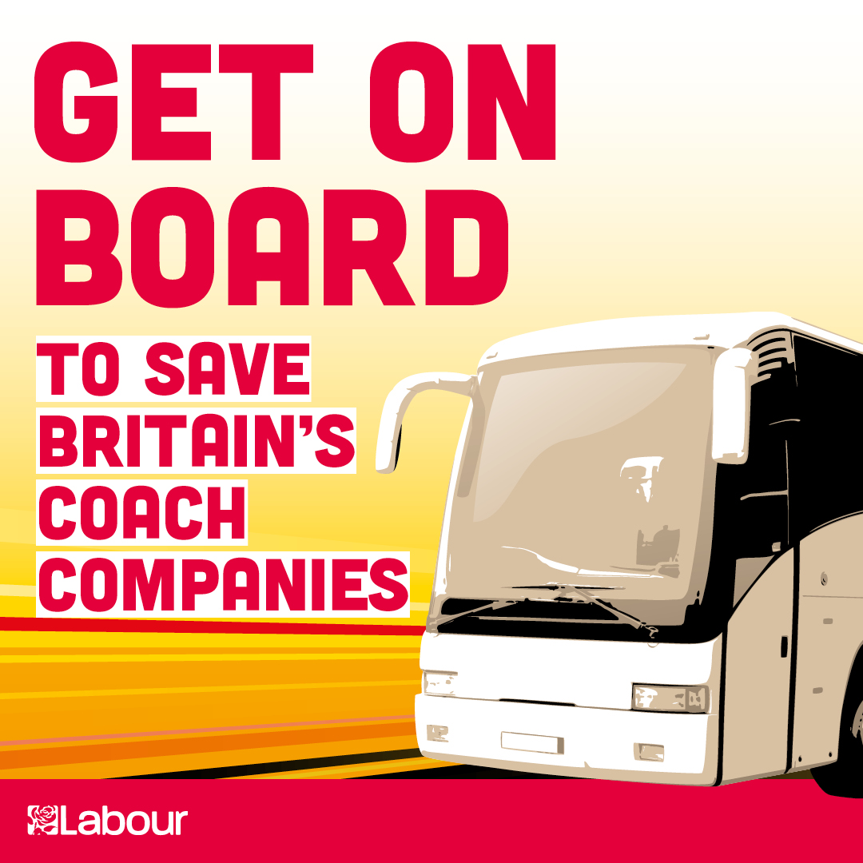

# **Model letter to the Government**

The Rt. Hon Grant Shapps MP

Secretary of State

Department for Transport

Great Minster House

33 Horseferry Road

London SW1P 4DR

xxx October 2020

Dear Secretary of State,

I am writing to you regarding the future of the coach industry.

The coronavirus crisis has reduced passenger numbers across all modes of transport since March. Whilst the Government is correct to enforce restrictions in order to maintain public safety, it is also important to recognise the need to mitigate the financial impact on transport operators. The Government was right to offer support packages for bus, rail and light rail operators, allowing them to provide crucial services safely, but it must not neglect the coach industry.

Tens of thousands of people across the country are employed directly by the coach industry and its long-term viability is critical for the hundreds of thousands of jobs supported down the supply chain, for the wider British tourism economy, to allow the public to visit family and friends and for children to go to school. Services enable essential rail replacement services, school trips and travel to sporting fixtures.

Coach companies tend to be family or locally run. As a result, the impact of coach firms going under could be widespread, devastating to communities and result in the loss of homes and livelihoods for small business owners across the country.

If coach firms do not make it through this difficult period, many activities will be unable to continue when we eventually transition out of the coronavirus crisis.

The Job Retention Scheme has been the only source of support for some companies, with industry experts such as the Confederation of Passenger Transport estimating that 80% of coach companies were unable to access the Coronavirus Business Loan Interruption Scheme.

Many of the difficulties arise from coach financing. Companies have been incentivised to purchase newer, cleaner vehicles in recent years and most are bought using financing of some kind. Repayments have been due throughout the crisis, even as demand for coach services has continued to be low.

The government needs to be acting across the economy to protect jobs and protect the services and sectors crucial for our recovery and for our country’s future. It is vital that the government works with trade bodies, trades unions, and coach companies to ensure that the support available can be accessed by coach firms and meets the challenges they face.

Finally, I know everyone in your department is working hard to do all they can at this trying time. We are grateful for their professionalism at this difficult time. We are calling for clear action in the spirit of constructive engagement.

Yours sincerely,

# **Model letter to constituents**

Thank you for contacting me regarding the coach industry.

It is absolutely right that the Government should be held to account. Labour has long been calling for action to support the sector. The Government has been slow to act and risks jeopardising the long-term future of many coach companies.

The coronavirus crisis has reduced passenger numbers across all modes of transport since March. Whilst the Government is correct to enforce restrictions in order to maintain public safety, it is also important to recognise the need to mitigate the financial impact on transport operators. The Government was right to offer support packages for bus, rail and light rail operators, allowing them to provide crucial services safely, but it must not neglect the coach industry.

Tens of thousands of people across the country are employed directly by the coach industry and its long-term viability is critical for the hundreds of thousands of jobs supported down the supply chain, for the wider British tourism economy, to allow the public to visit family and friends and for children to go to school. Services enable essential rail replacement services, school trips and travel to sporting fixtures.

Coach companies tend to be family or locally run. As a result, the impact of coach firms going under could be widespread, devastating to communities and result in the loss of homes and livelihoods across the country.

If coach firms do not make it through this difficult period, many activities will be unable to continue when we eventually transition out of the coronavirus crisis.

The Job Retention Scheme has been the only source of support for some companies, with industry experts such as the Confederation of Passenger Transport estimating that 80% of coach companies were unable to access the Coronavirus Business Loan Interruption Scheme.

Many of the difficulties arise from coach financing. Companies have been incentivised to purchase newer, cleaner vehicles in recent years and most are bought using financing of some kind. Some firms have been able to negotiate payment holidays during the crisis, but these will soon come to an end. Firms will then become liable for repayments but demand for coach services remains low, meaning a debt crisis is looming.

The government needs to be acting across the economy to protect jobs and protect the services and sectors crucial for our recovery and for our country’s future. It is vital that the government works with trade bodies, trades unions, and coach companies to ensure that the support available can be accessed by coach firms and meets the challenges they face.

I will keep pushing the Government to take action, as will my parliamentary colleagues.

Thank you once again for contacting me about this issue.

Yours sincerely,